**LAB # 06**



**CSE302L System Programming Lab**

Submitted by: ALI ASGHAR

Registration No: **21PWCSE2059**

Class Section: **C**

Submitted to:

**Engr. Abdullah Hamid**

**Lab Objectives:**

* To understand different Unix IO Commands
* Implement different Unix Commands.

**Lab Tasks:**

**Task 1:**

Write a program for parallel file copying using multiple processes.

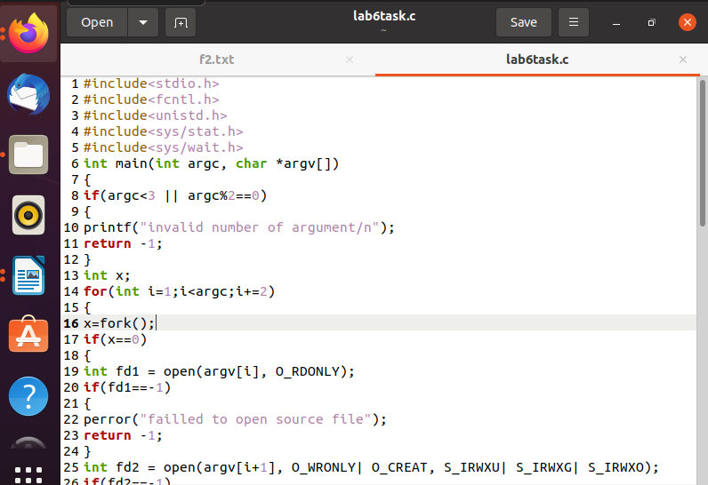

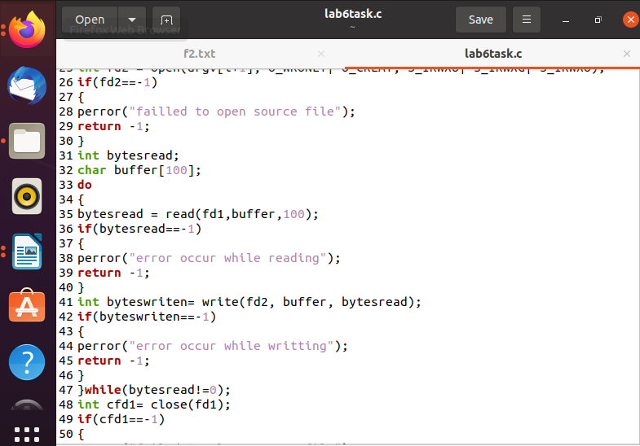

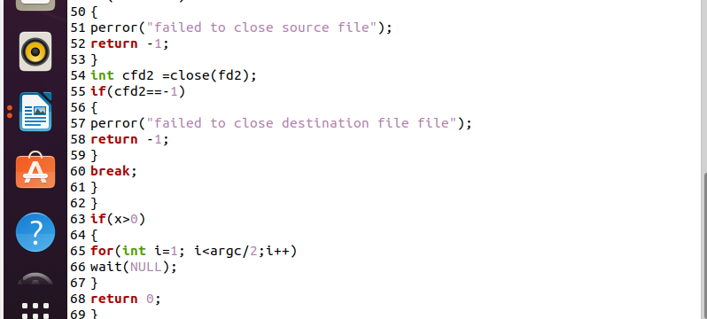

Output;

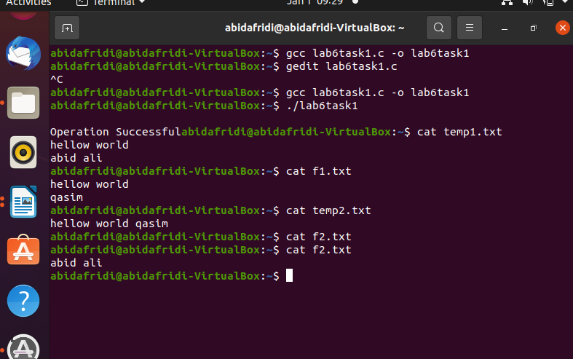

Task2

Implement “Cat” utility.

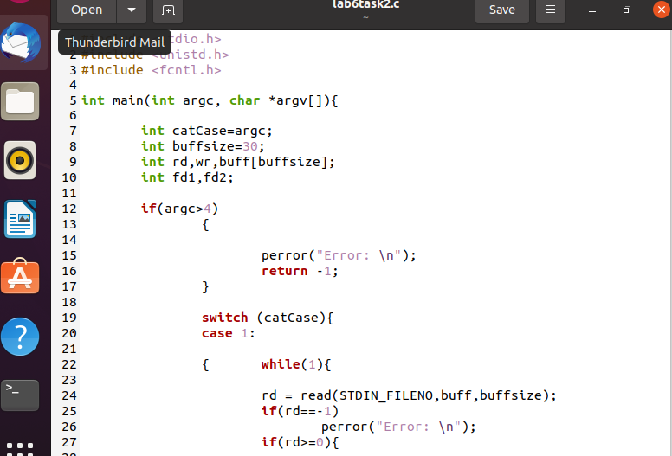

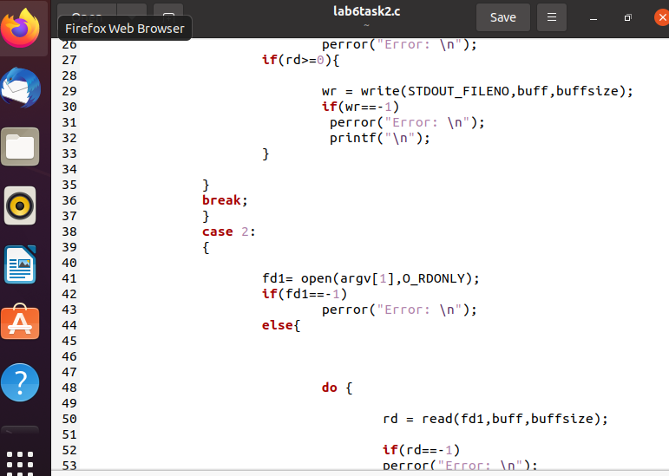

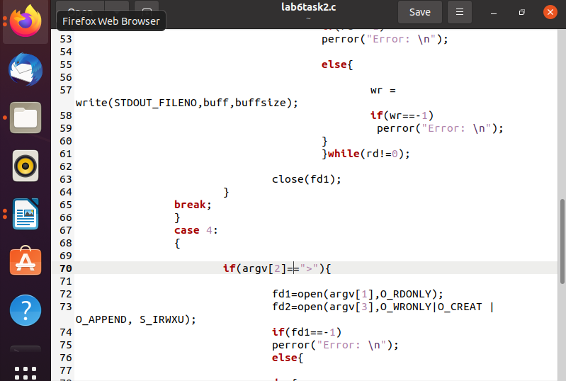

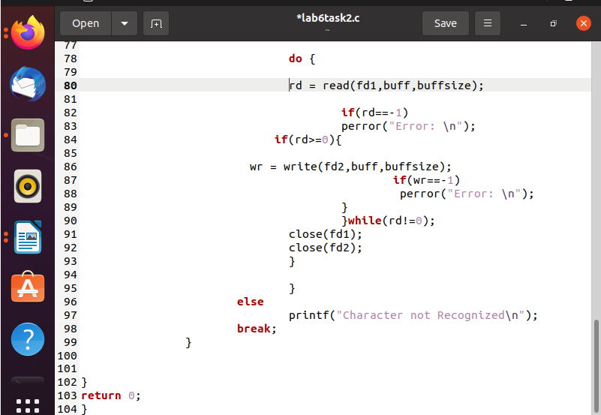

Case1

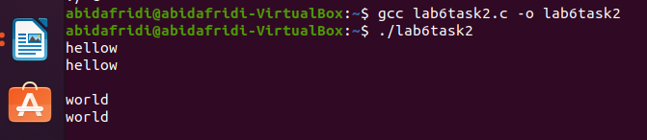

Case2;

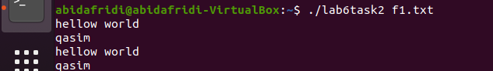

Case3;

